Web Questionnaires service
User Manual
Prepared by
Enriko Käsper, TripleDev
April 2015
Version 1.0
User Manual
Version management
No | Date | Changes | Author
1.0 | 22.04.2015 | Creation of the document | Enriko Käsper

Contents
1. Introduction 4
1.1 Purpose 4
1.2 Overview 4

Introduction

Purpose
The purpose of this document is to describe the Reportnet Web Questionnaires service (WebQ) anonymous users functionality and to guide the users through the process of creating and merging the XML files with webforms.
The document is mainly targeted for users who have to report data using webforms, but they are not privileged to do the reporting in Central Data Repository (CDR). This kind of users can use WebQ anonymously and create XML files using webforms. Another target group of the users is the national coordinators, who want to merge multiple XML files, gathered from regional level, into one file before doing the official submission in CDR.

Overview
The WebQ service allows data reporters to deliver data in XML files using online webforms. Data reporters do not need any other special software for filling in data, but a standard web browser (Internet Explorer, FireFox, Chrome) with Javascript support. There are two options of how to deliver data using webforms:
- the reporters can use WebQ anonymously and store the data files locally in their computers. This option is needed when the reporters do not have permissions in CDR envelopes to submit the delivery (eg. regional reporters). In this case the national coordinators with CDR access rights collect the regional XML files (eg. via e-mail), merge the files, if needed and upload the files in CDR envelope for official submission of the delivery.
- the reporters having applied to reporter role in CDR can access the webforms directly from envelopes via “Add or modify the questionnaire” links. In this case the CDR interacts with WebQ in background and WebQ service produces automatically valid XML files as deliveries in relevant CDR envelopes. The reporters can start to fill out an empty web form or they can pre-fill the web form with data coming from last year’s deliveries, if this option is implemented.

WebQ service is accessible at: http://webforms.eionet.europa.eu/

Create XML files using webforms
The WebQ service hosts different web forms for variety of data reporting obligations. The current user manual is created based on HaBiDes data reporting obligation, hence the webform is referred as “HABIDES+ reporting tool” from now on. The webform names are different for different reporting obligations.
To start up the creation of XML file, complete the following three steps:
- click on "Create new session file" button;
- select "HABIDES+ reporting tool" or any other webform from the list of file types;
- click on "Save file in session" button
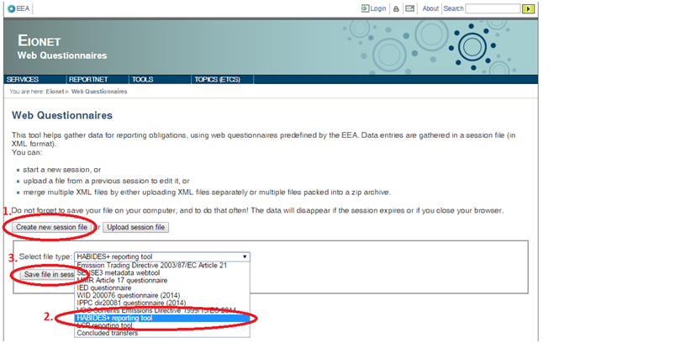Illustration 1: Create session file
As a result of these steps a new XML file will appear in the session files area named habides-derogations_1.xml. All the data inserted via the webform in the next steps will be stored in this XML file. Please remember that the file is stored online in the system only during your session and it will be deleted after your session expires or you close your internet browser. Thus download and save the file in your computer after you have finished the entering data.
If you have created the session file earlier and then downloaded it into your local computer, then you can re-edit the existing file by uploading it using the "Upload session file" button. As a result of upload the file will appear in the session files area similarly to the new session file.
The XML file types are automatically detected by the XML Schema location specified in the XML file root element.

To proceed with the reporting, click on the "Edit with 'HABIDES+ reporting tool' webform" link next to the session file name as displayed in the figure below.
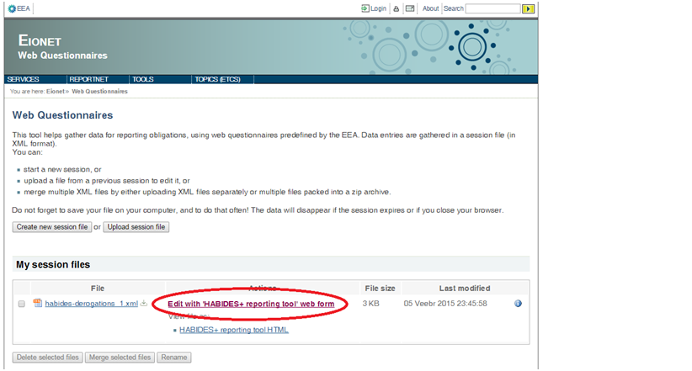Illustration 2: Edit session file in webform
Click on the file name to download the XML file after you have filled in the webform.
Hover your mouse on information icon in the right column to see more information about the XML file.

Merge XML files
Web Questionnaires Service provides XML merging functionality for National Coordinators to combine and check to the completeness of the XML files created by the Regional Reporters. Follow the steps below to complete the merging task.

Merging step 1: Upload multiple XML files
1. The first step is to upload XML files into session files area. Click on "Upload session file" button and select the XML file from your computer to accomplish this task. The uploaded files have to be well-formed XML files and they should conform to the official data reporting format specified in XML Schema. The root element of XML file has to contain attribute: xsi:noNamespaceSchemaLocation="http://dd.eionet.europa.eu/schemas/habides-2.0/derogations.xsd"
Before merging the files, you can review the uploaded XML files one by one either in editable web form by clicking on "Edit with 'HABIDES+ reporting tool' form" link or in a read-only printable format by clicking on "View file as: 'HABIDES+ reporting tool HTML" link.
2. Select the files to be merged by ticking the checkbox in front of the file names.
3. Click on the "Merge selected files" button and the merging result will be stored as one XML file in your computer. The file name is merged_files.xml
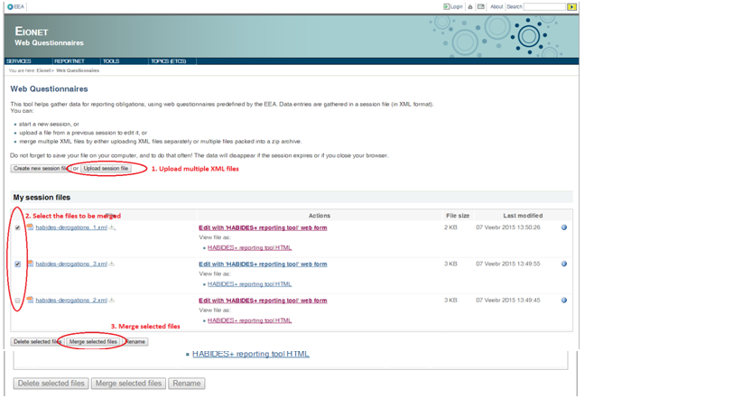Illustration 3: Merge XML files

Merging step 2: Validate the merged file
Before starting the submission in CDR it is advised to review the merging result in the webform. Upload the merged_files.xml into the WebQ sessions files area as you did with the other XML files in previous step.
You can review the merged XML file either in editable web form by clicking on "Edit with 'HABIDES+ reporting tool' form" link or in a read-only printable format by clicking on "View file as: 'HABIDES+ reporting tool HTML" link.

Merging step 3: Download the merged file
After reviewing the merged XML files in WebQ Service it is crucial to save the merging result in your computer to be able to start submission in CDR. Click on the merged_files.xml link in session files area to download the file in your computer.
Please note that for simpler handling of XML files in WebQ session files area, it is possible to use renaming functionality. Tick the file you want to rename and click on the "Rename" button. You can rename multiple files at the same time.

